AfricaConnect3
Supply, Support and Maintenance Framework Tender for Packet Layer Routing and Switching Equipment

Volume 0 - Information
Provision, Delivery, Installation, Support of IP Routing, Switching & Ancillary Equipment for the UbuntuNet Alliance

STATUS: Final
DISTRIBUTION: AFRICA CONNECT TECHNICAL PROJECT TEAM & BIDDERS

Date of Issue: | 29/07/2026
Dissemination Level | UbuntuNet Alliance Management
Owner: | UbuntuNet Alliance Procurement
Author | Phil Matthews
Reviewers | Joe Kimaili

Table of Contents

1 Introduction 4
2 Current Network 5
3 Structure of the Tender Documents 5
4 Timing and Communications 6
Annex A: Conditions for participating in this Procurement Exercise 7

Foreword

UbuntuNet Alliance reserve the right:
- to award one or more or no contracts whatsoever as a result of this procurement process;
- to add components to the scope of the required services or remove components from the scope of the required Services in any contract which may be awarded;
- to vary the bid timetable (including the content of the phases) as it considers appropriate at any time. Any material changes will be notified to the person each Bidder has nominated for contact purposes;
- to make whatever changes it sees fit to the structure or content of the procurement process, within the bounds of the relevant legislation;
- to withdraw this Invitation to Submit Outline Proposals (ITSOP) at any time or to re-invite Responses on the same or any alternative basis;
- to seek clarification in relation to the information submitted by the Bidders. The Bidders must respond promptly in writing; and
- to select a Response which is incomplete or not formatted in accordance with this ITSOP or not provided in the media required by this ITSOP regardless of whether other complete or more complete Responses or Responses formatted in accordance with this ITSOP were submitted by other Bidders.
Any expenditure, costs, liability, work or effort undertaken or incurred in proceeding and/or participating in this procurement ("Bidder Costs") is a matter solely for the commercial judgement of Bidders, and UbuntuNet Alliance will not be liable to reimburse or compensate the Bidders in respect of any of the Bidder Costs.

Information provided in response to this Invitation to Submit Outline Proposals (ITSOP) may be shared with any National Research and Education Network (NREN) that is a member of the UbuntuNet Alliance and/or their professional advisors. The information will be held in confidence and used solely for the purpose of this procurement and awarding any resultant framework agreements or contract(s).
The term “Bidder” will be used to describe economic operators who respond to this ITSOP.

Introduction

  - The overall objective of AfricaConnect2 is to contribute to the reduction of poverty and the digital divide by harnessing the potential of Information and Communication Technologies (ICTs) for sustainable development in Africa. The project seeks to do this through facilitating the creation, development and use of regional education and research communication networks and high-capacity Internet connectivity with a gateway to global research collaboration.

  - The success of the AfricaConnect2 project will be measured through the consolidation and improvement of the UbuntuNet network (resulting from the AfricaConnect 1 project), including the inclusion of new e-infrastructure services and the extension to newly ready countries.

  - The UbuntuNet Alliance will be taking this project forward in respect of Eastern and Southern Africa. The Alliance exists to coordinate research and education (R&E) networking in Eastern and Southern Africa on behalf of the region’s National Research and Education Networks (NRENs). It is the regional association of National Research and Education Networks (NRENs) in Africa. Initially established in 2005 by five emerging NRENs in Eastern and Southern Africa MAREN (Malawi), MoRENet, (Mozambique), KENET (Kenya), RwEdNet (Rwanda) and TENET (South Africa), its ambition was to secure high speed and affordable Internet connectivity for the African research and education community in Gb/s rather than in Kb/s.

  - Today, the Alliance’s membership is drawn from a range of countries including, The Democratic Republic of Congo, South Africa, Ethiopia, Kenya, Madagascar, Malawi, Mozambique, Rwanda, Sudan, Tanzania, Burundi, Botswana, Uganda, Zambia and Zimbabwe and its objectives are, on a non-profit basis, to:

- Develop and improve the interconnectivity between Research and Education Networking (REN) Participants in Africa and their connectivity with research and education networks worldwide and with the Internet generally;
- Develop the knowledge and skills of ICT practitioners in these institutions; and
- Provide related auxiliary services to Research and Education Networking (REN) Participants.

  - The Alliance is fully incorporated as a non-profit association in Malawi with financial and other secretariat functions.

  - The beneficiaries of AfricaConnect3 are the NRENs under the Alliance

  - Funding for the UbuntuNet Alliance network infrastructure has previously been provided by a research and development grant from DG INTPA which provides up to 80% of the total costs. The beneficiaries of the programme, the ESA-NRENs, are required to contribute at least 20% of the total funding in order to release the 80% from the EC.

  - This tender will establish a Framework Agreement (FA) for packet layer routing, switching and ancillary products, delivery and import thereof as well as installation and support throughout the region. It will support the extant regional research networking infrastructure as it continues to grow throughout the term of the AfricaConnect3 and likely beyond under future grant agreements. It will support the supply of new equipment to integrate with the extant Juniper network where we move forward with the establishment of new routes to newly joining NRENs in countries such as Botswana Zimbabwe, and possibly Madagascar. Later stages of the overarching programme of work under AfricaConnect3 or follow-on projects may be to look at future options for connecting into the WACREN network in West Africa (also funded through the Pan African Programme).

  - The FA will run for a term of up to eight years from the date of signature

  - As stated above, the Alliance reserves the right to award one or no contracts in respect of this procurement exercise. Bidders will be selected on the basis of evaluation criteria set out herein and the suitability of routing equipment and support options in the context of the extant network estate and investments already made.

  - There is no commercial re-sale or transit permitted over the UbuntuNet infrastructure. Bidders are required to consider the following aspects when considering their pricing strategy in respect of this tender:

- the non-commercial nature of the AfricaConnect project and the UbuntuNet Alliance;
- the nature of the funding in that it is a development aid grant;
- the special opportunities it will give for boosting research and education within Eastern and Southern Africa;
- low costs of access to reliable research networking for universities generates graduates who demand the same level of access in the workplace thus bringing the associated economic growth opportunities that long term strategic investments in research and education networking has successfully demonstrated and evidenced elsewhere in the World;
- the need for UbuntuNet Alliance to remain commercially relevant to its member NRENs in the region throughout the term of any agreement. The EC funding will only be used to build a sustainable financial model into the future so contracts must include provisions that ensure that any recurring charges allow the “not for profit” network operator for the region’s research and education networks to remain commercially relevant to its shareholder NRENs.

Current Network

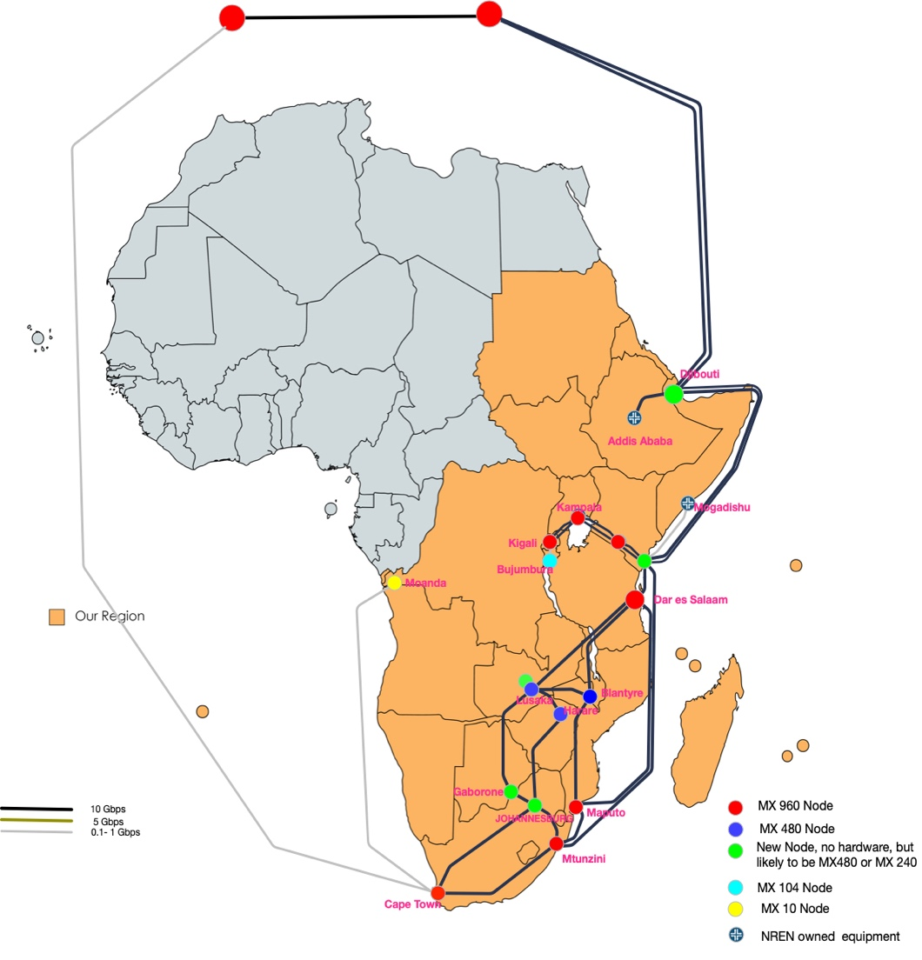

  - Volume 2 provides a list of all UbuntuNet Alliance assets that will be the subject of support during the term of any contracts awarded under a new framework. It also shows the locations of the equipment and the type of equipment that may require upgrades to the installed Juniper equipment during the term of the framework.

Structure of the Tender Documents

  - The tender is comprised of a number of documents, the order and contents of which is described below:

Volume | Name | Purpose of the Volume
0 | Information Document | An information document that sets out the evaluation criteria and methodology for the capacity procurement exercise.
1 | Supplier Questionnaire | The minimum criteria that bidders much be able to comply with in order to participate in the tender exercise
2 | Statement of Requirements and Bidder’s Response Questions | A statement of technical, commercial and qualitative requirements for Bidders to formally provide responses to.
3 | Contract Terms & Conditions | The Framework Agreement – this is the form of contract governing any contractual award.

Timing and Communications

  - Table 4.1 below, Procurement Plan, provides a provisional overview of the key stages and dates in this procurement process.

  - UbuntuNet Alliance reserves the right to change these dates as necessary, although it will seek to minimise any changes.

Packet layer equipment supply and support tender | Start | Finish
Publish Tender in Malawi Press – Issue tender documents | 01/08/2023 | 01/08/2023
Bidders preparing responses for ITSOP stage | 02/08/2023 | 01/09/2023
Receive completed responses to ITSOP | 04/09/2023 | 04/09/2023
Review completed responses to ITSOP, inc capability assessment and mandatory reviews | 04/09/2023 | 08/09/2023
Invite qualifying suppliers to face to face dialogue | 08/09/2023 | 08/09/2023
Host face to face dialogue sessions - GABORONE, BOTSWANA - Bidders to note dates please and reserve at least one day during this week | 18/09/2023 | 22/09/2023
Draft ITSFB documentation | 22/09/2023 | 29/09/2023
Publish ITSFB to participating Bidders | 29/09/2023 | 29/09/2023
Bidder response Time BAFO | 29/09/2023 | 13/10/2023
Receive final Bids, evaluate responses, recommend award and secure internal approval | 16/10/2023 | 30/10/2023
Issue intent to award contract | Early November
Debrief down-selected bidders and standstill period | Early November
Framework Agreement production | Late November
Signature | Late November
Call off contracts for support and router upgrades issued to highest scoring bidders | December
Table 4.1 – Procurement Project Plan
  - All communications between UbuntuNet Alliance and the Bidders must be via the procurement@ubuntunet.net email address. This is to provide a complete audit trail of communications, fair play, and consistency for all, and to ensure certainty in document exchange.

  - By participating in this dialogue procurement, Bidders are deemed to have accepted the Conditions for participating in procurement as set out in Annex A.

- Process – Phases of the Tender
Phase 1 – Proposal meets all Selection requirements
  - The Alliance will verify if a Bidder meets all the set Selection requirements as described in the Excel Questionnaire Where your organization does not meet all Selection requirements your response will be rejected and put aside.

Compulsory exclusion grounds
  - Besides the Selection requirements, the team will also check if there are grounds to reject a response because the Bidder must be excluded following one or more of the Mandatory Exclusion grounds described in Excel Questionnaire
  - If it is established that your organization must be excluded based on the answers your provided in the Questionnaire your proposal will be rejected and put aside.

Phase 2 – Response meets all Minimum requirements for the required goods and/or services
  - Assuming that there are no grounds to exclude your tender response, the team will verify if the response also meets all set Minimum requirements (minimum competencies) directly connected to the requirement as described in the introductory sections below. Where the response does not meet all minimum competencies it will be rejected and put aside.

Later Stages

  - The Alliance is publishing the ITSOP at the same time as the Selection or Qualifying Phase. Assuming that your organization has successfully passed the Selection / Qualifying stage, the Alliance will automatically review your ITSOP response and thereafter invite qualifying Bidders to participate in dialogue.

  - This document (Vol 2) is a detailed set of technical, service support and commercial requirements which contains the Award Criteria - at the ITSOP stage these are still considered to be draft requirements.

  - During the dialogue process, as our requirements are fine tuned to reflect market realities and the latest technological environment, the technical requirements may be more tightly formulated to ensure consistency across all bidders and ensure fair and transparent treatment of all participating Bidders.

  - At this ITSOP stage, the draft Framework Agreement and Call Off Terms and Conditions shall also be published and a key strand of the dialogue agenda (see timetable) will be the review of the contract terms and conditions so that we can arrive a set of contract terms agreeable to all parties that meets the Alliance’s commercial requirements whilst protecting the taxpayer’s investment.

  - Details on the format of the dialogue process will be provided as and when bidders are invited to the face to face meetings in Botswana or South Africa during September.

- Demonstrating Capability
  - Within the Volume 1 document that you should have downloaded from the UbuntuNet Alliance procurement pages, you will find a number of mandatory competencies, that your organization must be able to demonstrate in order to further participate in the tender exercise.

  - In order to assess if your organisation qualifies as a suitable and capable supplier, you must submit evidence that you are genuinely capable of supplying the equipment and performing all of the associated support services that are within the scope of this tender.

  - The assessment is of a pass or fail nature and Bidders must provide the complete customer references to support the independent verification of all submissions.

  - Proof must be provided in the form of customer references (see Volume 1) which must evidence the specific competences required.

  - This must be by means of a list of the principal deliveries effected and the main services provided over at the past three years, with the sums, dates and recipients, whether public or private, clearly stated.

  - Bidders must be able to evidence their track record in respect of supplying equipment and related support services, in respect of packet layer platforms for those customers who are operating in the network, carrier level telecommunications, or Internet sector.

  - Each reference provided must be able to evidence at least one of the core competences required.

  - You must demonstrate that for at least 12 consecutive months, at any point in the last 3 years, (Mid 2020 <> May 2023) that your organization has been supplying and supporting all the packet layer routing products and support services listed below. It is not sufficient to show a track record in one or two areas - all areas are required:

  - These competencies are:

- Capability Area 1 - End to end supply of carrier class packet layer routing equipment - this means the seamless supply of equipment from the point of order including the provision of accurate BoM information against a defined set of bandwidth and dimensioning requirements, through to delivery at the final location with all relevant taxes properly managed.

- Capability Area 2 – Design, installation, configuration, optimization, commissioning and integrating, error testing and decommissioning – this mean deploying the equipment and migrating the associated services from the old router and onto the new platform following a period of satisfactory acceptance testing, and evidence of the ability to manage the entire process from end to end in terms of project management and planning resources. Decommissioning means the de-installation services associated with the removal of the existing packet layer routing equipment once any new equipment is in place and the connectivity service is ready to migrate (or has been migrated).

- Capability Area 3 – Carrier Class Packet Layer Routing Equipment first line maintenance and on-site/ remote support including spares supply and stockholding – this means evidence of your capability to provide, by Q1 2024, a solution for onsite spares support, and/or be on site within 4 hours of initial request, in respect of the required equipment in the cities and countries listed in the Annexes to Volume 2 – ITSOP.

Annex A: Conditions for participating in this Procurement Exercise
General
  - UbuntuNet Alliance is using a Dialogue procedure emulating the rules set out within the European Procurement Directive (24/14/EC) and bidders are referred to those Regulations.
  - Bidders are deemed to understand the processes that UbuntuNet Alliance is following under those Regulations and all applicable European Legislation and case law.
  - Bidders participate in the process and submit detailed Solutions in the knowledge, and on the understanding and acceptance that these conditions apply to the process and agree these terms in all respects.
  - It is the responsibility of each Bidder to ensure that they have all of the information they need to prepare their detailed Solutions.
Surveys, Inspections and Investigations
  - Bidders may carry out surveys, inspections and investigations at their own cost.
Bidding Costs
  - Each Bidder shall bear its own costs of bidding. UbuntuNet Alliance reserves its position as to whether or not it will enter into contractual arrangements and participation in the procurement is entirely at the Bidder’s risk. UbuntuNet Alliance shall bear no liability whatsoever for the outcome of the procurement and shall not be liable for the costs of detailed Solutions’ preparation, fine-tuning, or any loss of profit or other economic loss incurred by Bidders as a result of this competitive process whatsoever (whether or not a contract is concluded with that Bidder, another Bidder or not at all).
  - Bidders participate in this process and submit detailed Solutions in the knowledge and understanding that this is the case.
Confidentiality
  - Subject to the exceptions referred to in paragraph 1.8.4.1, the information in this ITSOP is being made available by UbuntuNet Alliance on condition that:
    - Bidders shall at all times treat the Information as confidential;
    - Bidders shall not (or allow anyone else to) disclose, copy, reproduce, distribute or pass the Information to any other person at any time or allow any of these things to happen;
    - Bidders shall not use the Information for any purpose other than for the purpose of making (or deciding whether to make) Solutions; and
    - Bidders shall not contact the media in relation to UbuntuNet Alliance, the procurement or this ITSOP nor make any statement or pass comment without the express approval of UbuntuNet Alliance in writing. Bidders shall not undertake (or permit to be undertaken) at any time, whether at this stage or after any contract award, any publicity activity with any section of the media in relation to UbuntuNet Alliance other than with the prior written agreement of UbuntuNet Alliance. Such agreement shall extend to the content of any publicity. In this paragraph the word ‘media’ includes, without limitation, radio, television, other broadcast media, newspapers or other print media, trade and specialist press, the Internet and e-mail accessible by the public at large and the representatives of such media.
      - Bidders may disclose, distribute or pass Information to another person (including but not limited to, for example legal advisers, the Bidder's insurers) if either:
      - This is done for the sole purpose of enabling Solutions to be made and the person receiving the Information undertakes in writing to keep the Information confidential on the same terms as set out in this paragraph ; or
    - The Bidder obtains the prior written consent of UbuntuNet Alliance in relation to such disclosure, distribution or passing of Information.
      - UbuntuNet Alliance may disclose detailed information relating to Solutions to its or any of the NRENs’, directors, officers, employees, agents, auditors or advisers. UbuntuNet Alliance also reserves the right to disseminate information that is materially relevant to the Contract to all Bidders, even if the information has only been requested by one Bidder, subject to the duty to protect any Bidder's commercial confidence in its Solutions. UbuntuNet Alliance will act reasonably as regards the protection of commercially sensitive information relating to the Bidder in the light of the latest published guidance on this area.
Accuracy of the Information and liability of UbuntuNet Alliance and their advisers:
    - This ITSOP has been prepared by UbuntuNet Alliance in good faith but does not purport to be comprehensive or to have been independently verified. Bidders should not rely on the Information and should carry out their own due diligence checks and verify the accuracy of the Information. Nothing in this ITSOP is or shall be a promise or representation as to the future.
    - Bidders considering entering into a contractual relationship with UbuntuNet Alliance should carry out their own due diligence, make their own enquiries and investigations (and shall be deemed to have done so). The subject matter of this ITSOP shall only have contractual effect when it is contained in the express terms of an executed Contract.
    - None of UbuntuNet Alliance, its members, directors, officers, employees, agents, auditors or advisers make any representation or warranty as to, or accept any liability or responsibility in relation to, the adequacy, accuracy, reasonableness or completeness of the Information or any part of it (including but not limited to loss or damage arising as a result of reliance by the Bidder on any of the Information contained in this ITSOP).
    - makes no representations or warranties regarding the Bidder's financial status or stability, technical competence or ability in any way to carry out the Project.
Canvassing, non-collusion and other grounds for rejection of bids
  - Any Bidder who, in connection with this Project:
    - Offers any inducement, fee or reward to any member or officer of UbuntuNet Alliance or any person acting as an adviser for UbuntuNet Alliance in connection with the Project; or
    - Canvasses any member or officer of UbuntuNet Alliance or any person acting as an adviser for UbuntuNet Alliance in connection with the Project; or;
    - Contacts any officer of UbuntuNet Alliance prior to the Contract being awarded about any aspect of the Project in a manner not permitted by this ITSOP (including without limitation a contact for the purposes of discussing the possible transfer to the employment of the Bidder of such officer for the purpose of the Project), or;
    - Is liable for the commission of a cartel offence under the Enterprise Act 2002 by any persons connected with the Bidder concerned, will be disqualified (without prejudice to any other civil remedies available to UbuntuNet Alliance and without prejudice to any criminal liability which such conduct by a Bidder may attract).
Non-collusion
  - Any Bidder who, in connection with this Project:
    - Fixes or adjusts the amount of his Solutions or bid by or in accordance with any agreement or arrangement with any other Bidder; or
    - Enters into any agreement or arrangement with any other Bidder that he shall refrain from making Solutions or bid or as to the amount of any Solutions or bid to be submitted; or
    - Causes or induces any person to enter such agreement as is mentioned in either paragraph above or to inform the Bidder of the amount or approximate amount of any rival Solutions or bid for the Project; or
    - Offers or agrees to pay or give or does pay or give any sum of money, inducement or valuable consideration directly or indirectly to any person for doing or having done or causing or having caused to be done in relation to any other Solutions or bids or proposed Solutions or bids for the Project any act or omission; or
    - Communicates to any person other than UbuntuNet Alliance the amount or approximate amount of his proposed Solutions or bids (except where such disclosure is made in confidence in order to obtain quotations necessary for the preparation of the Solutions or bids (for example, for insurance or a parent company guarantee), may be disqualified (without prejudice to any other civil remedies available to UbuntuNet Alliance and without prejudice to any criminal liability that such conduct by a Bidder may attract).
Other reasons for rejection of bids
  - Bidders will be excluded from participation in a procurement procedure if:
    - they are bankrupt or being wound up, are having their affairs administered by the courts, have entered into an arrangement with creditors, have suspended business activities, are the subject of proceedings concerning those matters, or are in any analogous situation arising from a similar procedure provided for in national legislation or regulations;
    - they have been convicted of an offence concerning their professional conduct by a judgment which has the force of res judicata;
    - they have been guilty of grave professional misconduct proven by any means which the Beneficiary can justify;
    - they have not fulfilled obligations relating to the payment of social security contributions or the payment of taxes in accordance with the legal provisions of the country in which they are established or with those of the country of the Beneficiary or those of the country where the contract is to be performed;
    - they have been the subject of a judgment which has the force of res judicata for fraud, corruption, involvement in a criminal organisation or any other illegal activity detrimental to the Communities' financial interests;
    - they are currently subject to an administrative penalty referred to in section 2.3.5 of the Practical Guide to contract procedures for EC external actions;
then UbuntuNet Alliance may reject or not consider a Final Bid (including any Solution submitted by that Bidder).
Copyright
  - The copyright in this ITSOP is vested in UbuntuNet Alliance and may not be reproduced, copied or stored in any medium without the prior written consent of UbuntuNet Alliance. This ITSOP, and any document issued as supplemental to it, are and shall remain the property of UbuntuNet Alliance and must be returned upon demand.
UbuntuNet Alliance’s right to reject Solutions
  - The issue of this ITSOP in no way commits UbuntuNet Alliance to award any Contract pursuant to this ITSOP process and UbuntuNet Alliance shall be able in its sole discretion to withdraw from the procurement with any Bidder or all Bidders at any time.
  - UbuntuNet Alliance may (but shall not be obliged) at its discretion but always acting proportionately and in accordance with the law to deselect a Bidder or a Solution if (without limitation)
  - the price is unaffordable;
  - the Solution places excessive risk on UbuntuNet Alliance;
  - the Solution scores below the satisfactory threshold in any area (as described further in the evaluation criteria);
  - the Solution is incomplete, misleading or inaccurate.
Amendments to the Documents
  - UbuntuNet Alliance reserves the right to issue amendments or modifications to the ITSOP. These will be issued to all Bidders simultaneously and Solutions will be assumed to take account of any such modifications and amendments.
Sub-contractors
  - Where a Bidder intends to use a sub-contractor it will be the responsibility of the Bidder to provide the sub-contractor with all the necessary information (having regard to the provisions relating to confidentiality in this ITSOP). Where information about a Bidder is requested in this ITSOP, such information must be given about all sub-contractors of that Bidder.
Validity of offers
  - Offers in response to this Tender should be valid until 30th June 2024.

